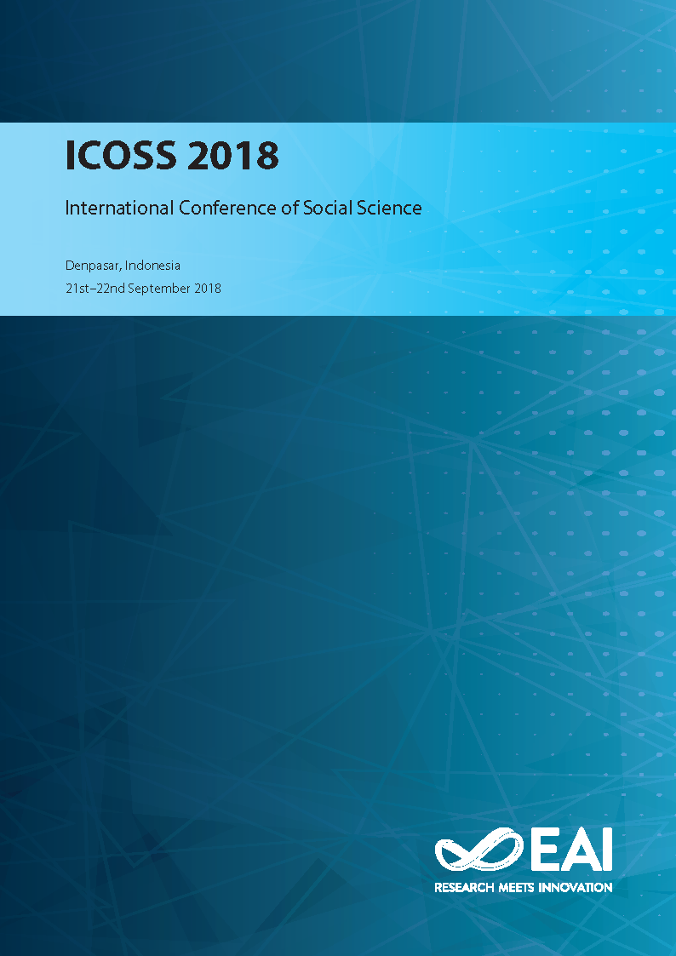
ICOSS 2018

ICOSS
Proceedings of International Conference of Social Science, ICOSS 2018, Denpasar, Indonesia

Social science is all the field of science that deals with human beings in their social context or all areas of science that people study as members of society. A s people who are engaged in social science, we must be sensitive to social phenomena in society, especially those associated with touris…
more »
Editor(s): Umiyati Mirsa, Budiarta I Wayan, Kasni Ni Wayan and Nahak Simon
Publisher EAI
ISBN 978-1-63190-166-9
ISSN 2593-7650
Conference dates 21st–22nd Sep 2018
Location Denpasar, Indonesia
Appeared in EUDL 28th Jan 2019
Copyright © 2019–2019 EAI

url : http://eudl.eu/proceedings/ICOSS/2018

